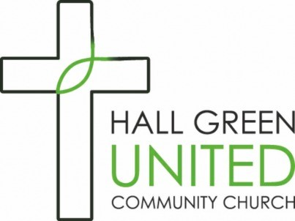

*Reply to*:

609 Reddings Lane

B28 8TE

or

valdickens@hgucc.org.uk

January 2025

Dear Applicant,

**POST OF PART-TIME ADMINISTRATOR**

Thank you for your interest in this vacancy. You will find here the following four documents:

* Job Description
* Person Specification
* Application form
* Equal Opportunities Monitoring Form

If you wish to make an application, please print and complete the Application Form and Equal Opportunities Monitoring forms and either return them to me at HGUCC, 609 Reddings Lane, Birmingham, B28 8TE marked “Private & Confidential” or scan and email them to [valdickens@hgucc.org.uk](mailto:valdickens@hgucc.org.uk) by the closing date which is Friday 28th February 2025**. I**t is essential that every section of the application form is completed. Please read the job description and person specification carefully as these form the basis of our shortlisting process.

We intend that shortlisted candidates will be interviewed during the week commencing Monday 17th March 2025. If you do not receive an invitation please assume that on this occasion you have not been shortlisted.

It is good to have your interest in this post and we look forward to receiving your application.

 Yours sincerely

Val Dickens

Secretary to the Trustees